# Steps followed to set up the demo system

1. Git clone --branch BabyVijayaShree https://github.com/christinajjy/Engage.git
2. Set up the db.

Copy [https://github.com/christinajjy/Engage/blob/sanjana/sql/Querries.sql to Engage\src\Database\Querries.sql](https://github.com/christinajjy/Engage/blob/sanjana/sql/Querries.sql%20to%20Engage%5Csrc%5CDatabase%5CQuerries.sql).

Moved ALTER TABLE USERS statements before the INSERT INTO users.

source Querries.sql

1. Set up the rest api and run it in intellij.

Change application.properties to point to the correct db with user/password.

1. Setup password for users using user-requests.rest file from visual studio. Use the command /userlogin/change-password.
2. Set up npm – cd Engage. run npm install. Run npm start.
3. Login using user - jennifersmith@gmail.com
4. Register pictures - Rename the App.js to App.js.tmp Rename AppForPictures.js to App.js .

Use the ui to register the pictures against their ids.

Added 2 more pictures for Jennifer and Emily.

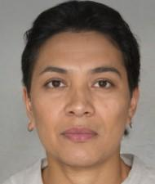

1. Login using user - [jennifersmith@gmail.com](mailto:jennifersmith@gmail.com)

Create a post

The recent success of the project ‘TM Engagement Portal’ is proof of the outstanding teamwork displayed by everyone involved. The team’s ability to collaborate effectively and support each other was truly impressive.



Create a Shout out

A big shout-out to the members of the project ‘TrendTrack’ for their perseverance and dedication. Despite endless hurdles, they remained focused and found creative solutions. We love to see this type of dedication.



Create a bright spark award

Congratulations, your hard work and dedication every single day are truly appreciated. I wanted you to know that your consistent focus and positive attitude are a great inspiration to everyone around you.

Login as Bharat Reddy and create a Post

Congratulations to the team ‘TechTrack’ on the amazing news! This is an incredible milestone, and you deserve the spotlight to celebrate the moment."



Login as Nethra and create an One Team Award

Congratulations to the entire team for giving their best efforts and successfully completing this project. Let's continue this success until we reach the top of the industry. Surely this team can get there.



Create a ‘bright spark award’

Congratulations on leading the project ‘TechTrack’ to success. Your perseverance and commitment are truly inspiring. Thank you for all your effort and hard work.

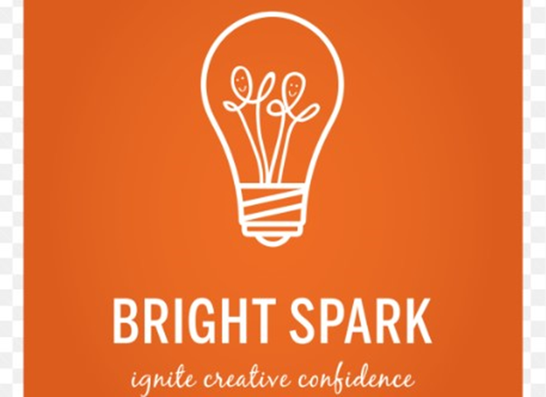

Create a ‘Above and beyond’ award

Thank you for going above and beyond. Thank you for your unwavering dedication and commitment to our team's goals. Your hard work, perseverance, and reliability are truly commendable. Your contributions do not go unnoticed, and we appreciate everything you do.



Create a Shout Out

Today, we want to celebrate Daniel, our unsung hero. Your consistent dedication and hard work behind the scenes make a world of difference. Thank you for being the backbone of our team!

Create a Shout Out

Kudos for not only delivering outstanding quality but doing it at lightning speed. Your efficiency and dedication are truly commendable!

Create a Post

On Sep 15, 2024, Our Retail Group celebrated the successful launch of our ‘EcoSmart’ product line, a collection of sustainable and eco-friendly products ranging from clothing and home goods to personal care items. This milestone was significant as it marked our commitment to environmental responsibility and innovation in product offerings. We engaged in sustainable sourcing and certification which ensured that the ‘EcoSmart’ product line adhered to high sustainability criteria. Our company also invested in R&D to develop products that were not only eco-friendly but also high-quality and affordable. We launched a comprehensive marketing campaign to promote the ‘EcoSmart’ line, including in-store displays, online ads, and social media content. We enabled this through employee training and community engagement programs.

This resulted in sales growth, brand image enhancement and increased customer engagement.



Captions for awards

* "Celebrating the dream team that made it happen! Thank you for your hard work and dedication. Your efforts have led us to success!"
* "Teamwork makes the dream work! I'm honored to award this amazing team for their tireless efforts and commitment to excellence. You rock!"
* "Success is sweet, but it's even sweeter with an incredible team like ours! Thank you for your efficient efforts and hard work. You deserve it!"
* "The ultimate reward is seeing your team thrive! Congratulations to my rockstar team for their well-deserved recognition. Keep shining!"
* "When teamwork and dedication come together, magic happens! I'm so proud to award this fantastic team for their outstanding performance. Cheers to many more successes!"

Caption for above and beyond

* "Recognizing the extraordinary efforts of our shining stars! This team has gone above and beyond, exceeding expectations and making a significant impact. Keep soaring!"
* "Beyond the call of duty, beyond the ordinary, and beyond amazing! Congratulations to our 'Above and Beyond' award winners. Your dedication inspires us all!"
* "Excellence is not a destination, but a continuous journey. Our 'Above and Beyond' team has embodied this spirit, consistently delivering exceptional results. Cheers to their unwavering commitment!"
* "When passion meets perseverance, the outcome is truly remarkable. Our 'Above and Beyond' team has demonstrated this and so much more. Thank you for your tireless efforts!"
* "Surpassing expectations, breaking barriers, and making a lasting impact. Our 'Above and Beyond' team is the epitome of excellence. Keep pushing boundaries and inspiring us all!"

Caption in trip post  
Unforgettable moments with the best team ever! 🤩 We recently went on an office trip and had the most incredible time together! 🌈 From team-building activities to exploring new places, we made memories that will be etched in our hearts forever. 💕 The laughter, the jokes, the adventures... we shared it all! 🎉🏞️ This trip was a reminder that when we work together and support each other, we can achieve anything! 💪

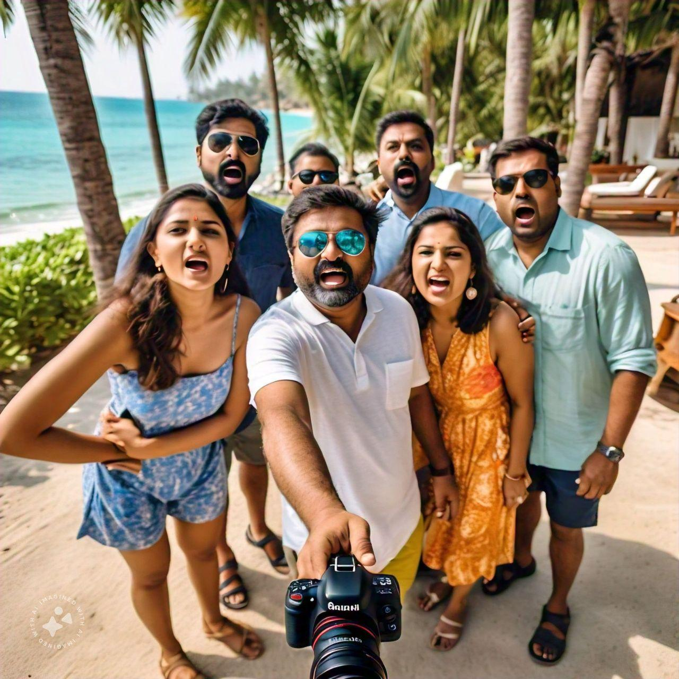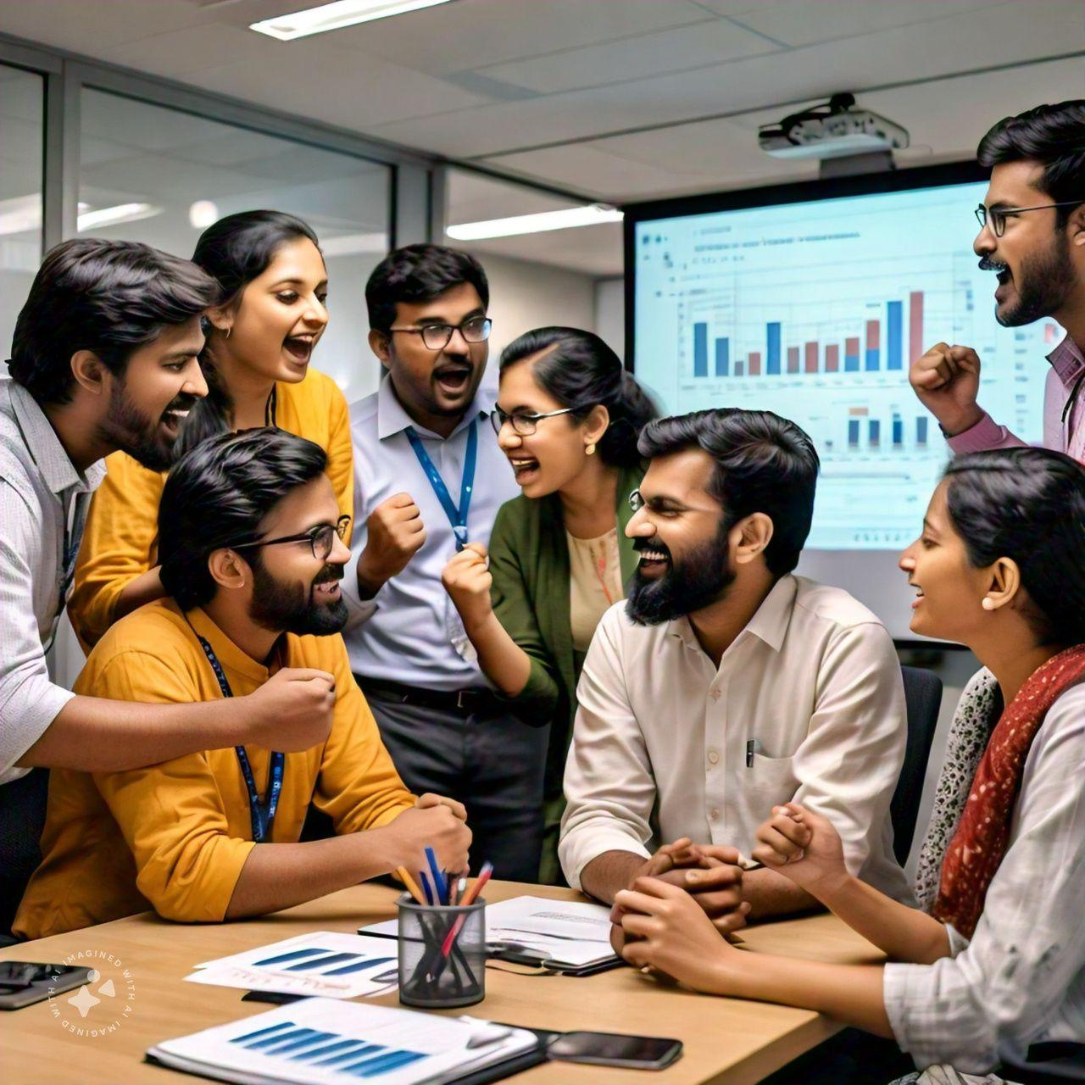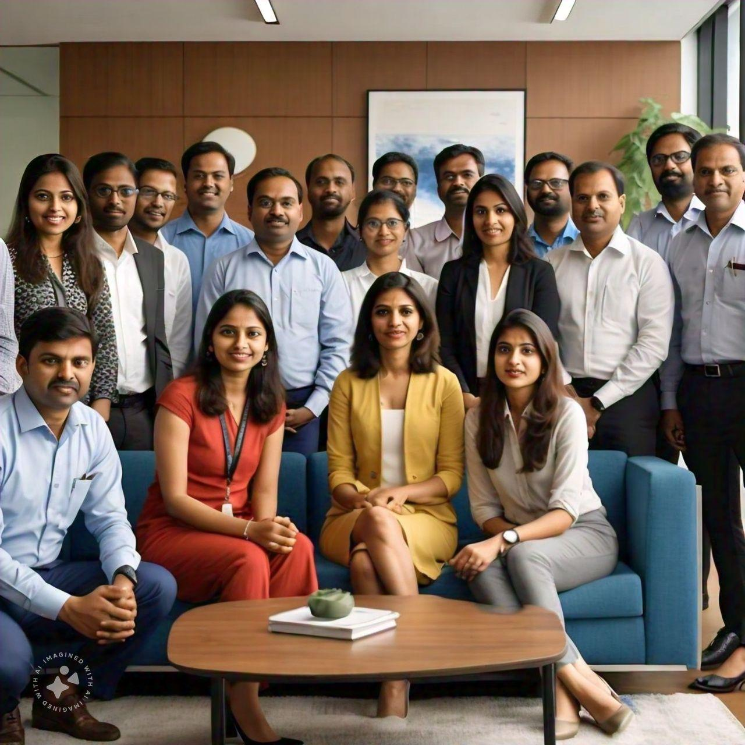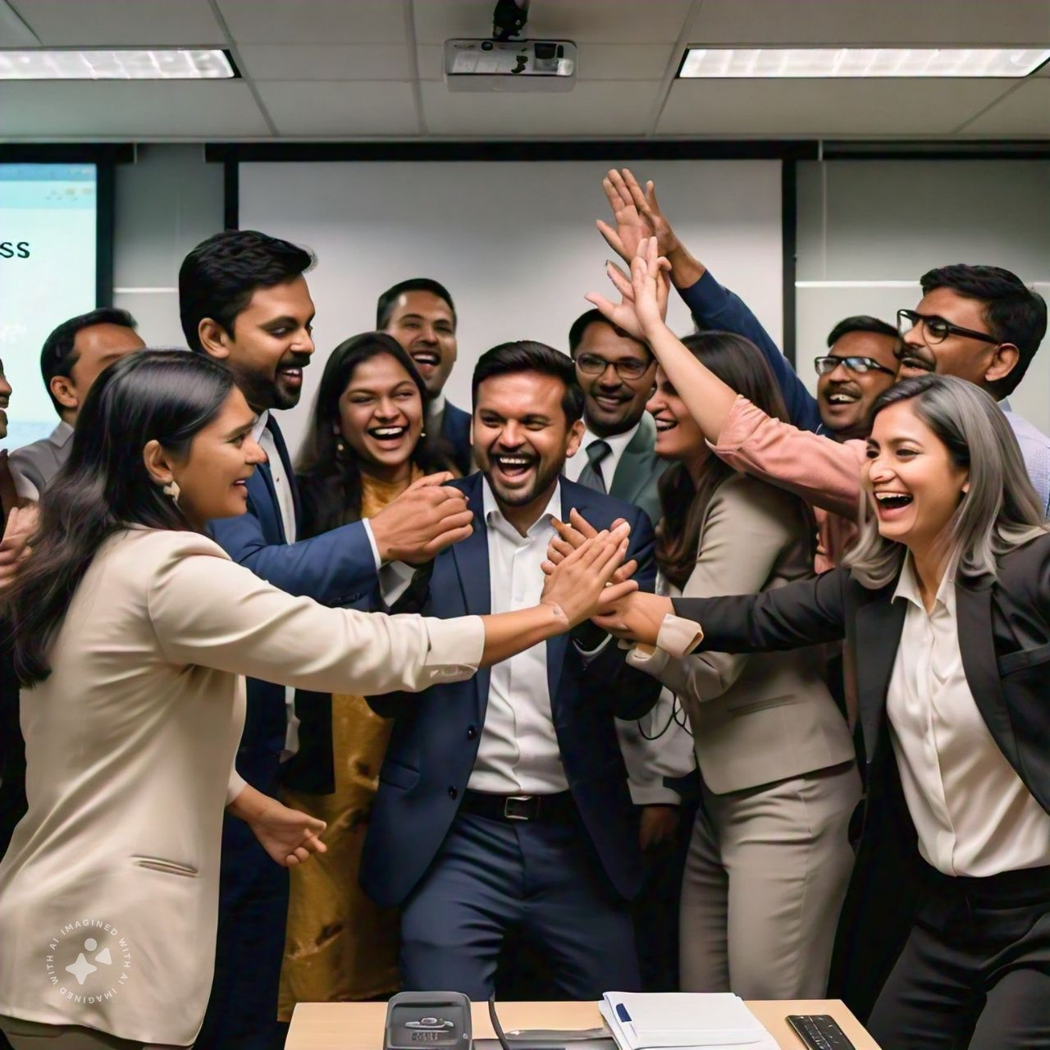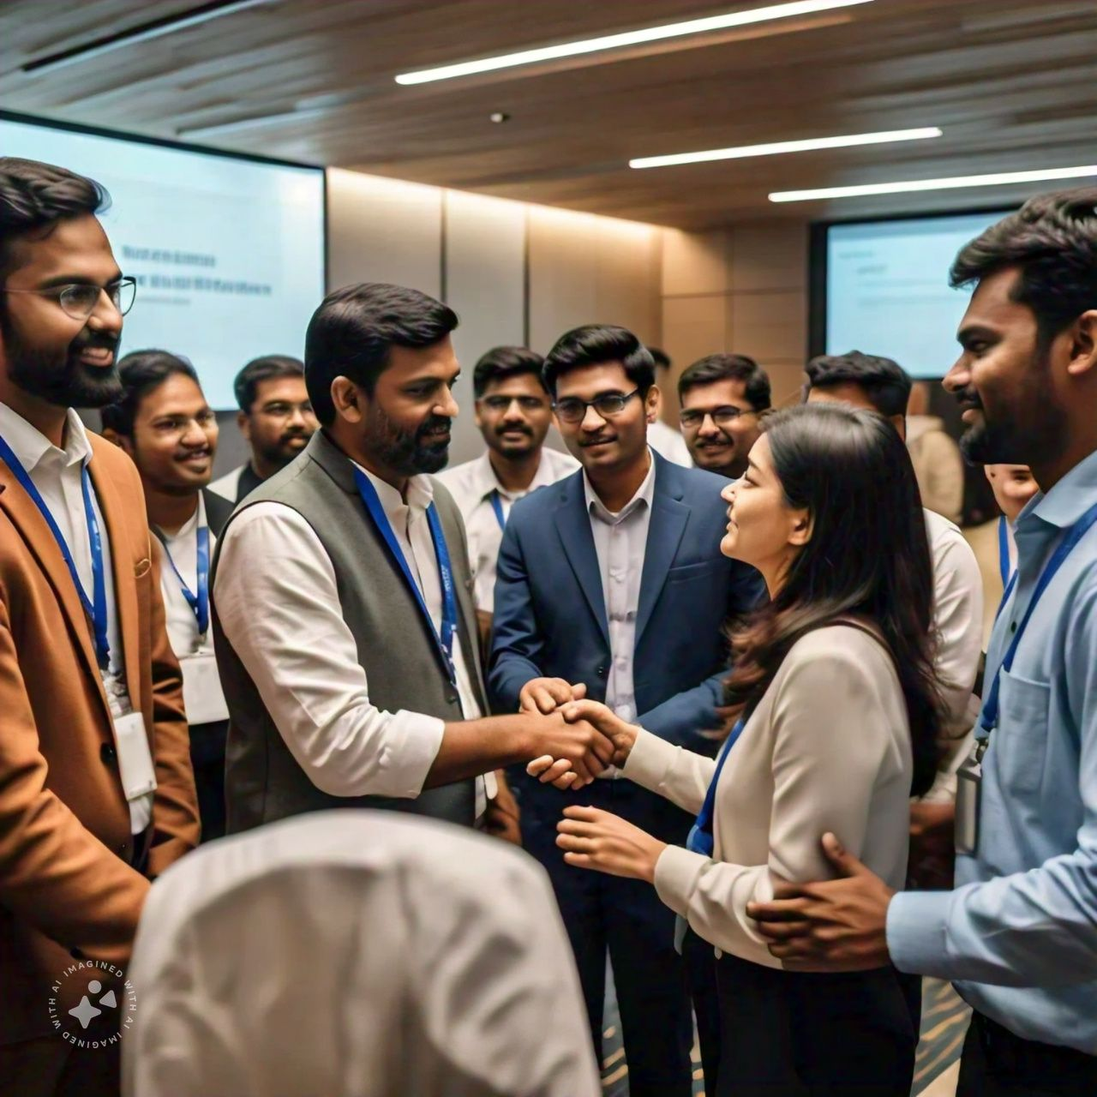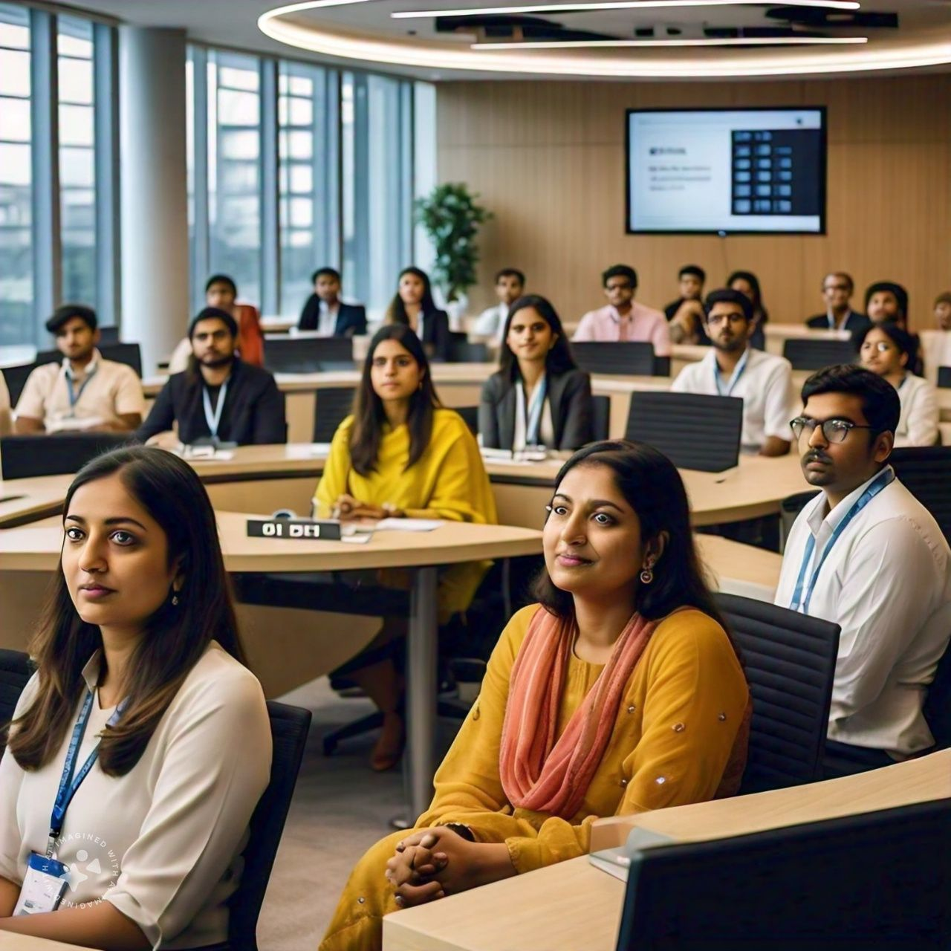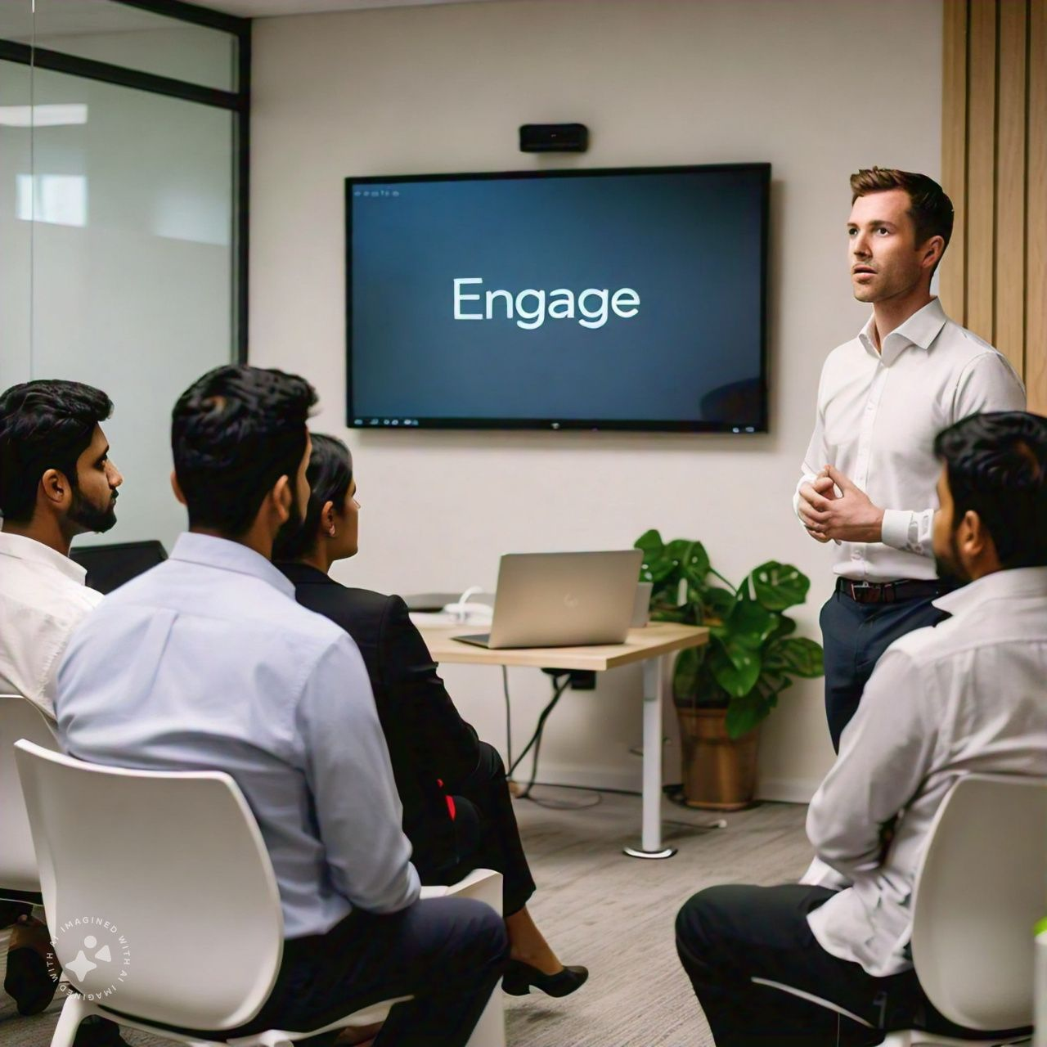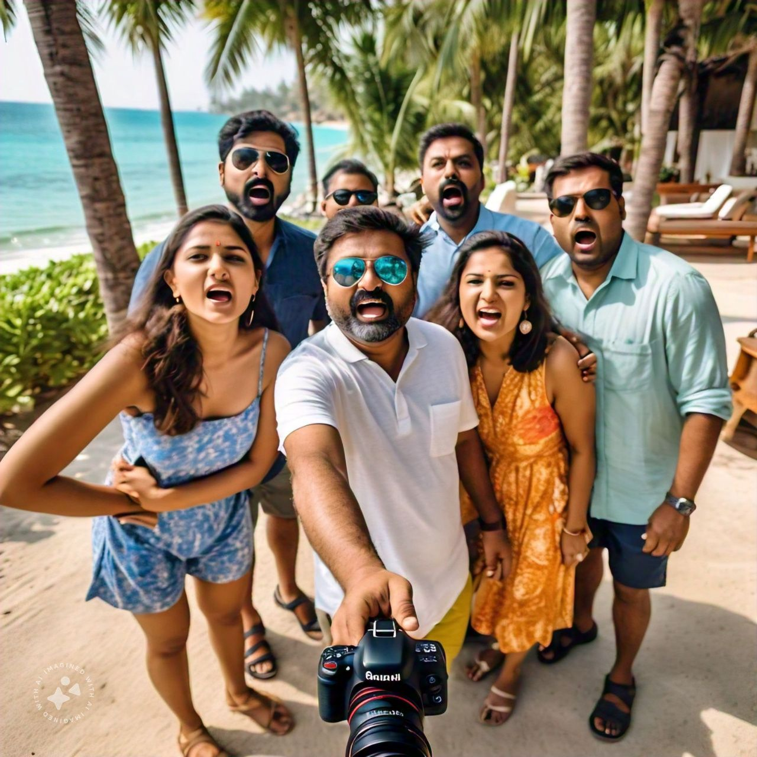

Caption for team success  
WE DID IT!!! 🎉💥 Over the moon with pride and joy as we celebrate the massive success of our team's hard work and dedication! 🙌 Our latest project was a huge challenge, but we crushed it with flying colors! 💪 The results are astounding, and we can't wait to see the impact of our work. 🤩 This is what happens when talent, teamwork, and passion come together! 💫 Cheers to each and every one of my incredible teammates - you're the real MVPs! 🥳 Let's keep pushing boundaries and achieving greatness together!